Angle Conversion

- Minutes & seconds degrees into decimals

The size of an angle could be stated this way: 40 degrees, 20 minutes, 50 seconds.
There are symbols that are used when stating angles using degrees, minutes, and seconds. Those symbols are show in the following table.
Symbol for degree:
Symbol for minute:
Symbol for second:
So, the angle of 40 degrees, 20 minutes, 50 seconds is usually written this way:
How could you state the above as an angle using common decimal notation? The angle would be this many degrees, (* means times.):
40 + (20 * 1/60) + (50 * 1/60 * 1/60)
That is, we have 40 full degrees, 20 minutes - each 1/60 of a degree, and 50 seconds - each 1/60 of 1/60 of a degree.
Work that out and you will get a decimal number of degrees. It's 40.34722...

- Decimal degree into minutes & seconds

Going the other way is a bit more difficult. Suppose we start with 40.3472 degrees. Can we express that in units of degrees, minutes, and seconds?
Well, first of all there are definitely 40 degrees full degrees. That leaves 0.3472 degrees.
So, how many minutes is 0.3472 degrees? Well, how many times can 1/60 go into 0.3472? Here's the same question: What is 60 times 0.3472? It's 20.832. So, there are 20 complete minutes with 0.832 of a minute remaining.
How many seconds are in the last 0.832 minutes. Well, how many times can 1/60 go into 0.832, or what is 60 times 0.832? It's 49.92, or almost 50 seconds.
So, we've figured that 40.3472 degrees is almost exactly equal to 40 degrees, 20 minutes, 50 seconds.
(The only reason we fell a bit short of 50 seconds is that we really used a slightly smaller angle in this second half of the calculation explanation. In the original angle, 40.34722... degrees, the decimal repeats the last digit of 2 infinitely, so, the original angle is a bit bigger than 40.3472.)
- Take your three sets of numbers and put them together, using the symbols for degrees (°), minutes (‘), and seconds (“) (i.e. 121°8'6”)
Special right angle triangles
There are two types of right triangles which often appear in Building Site Surveying & Set Out 1
One of these right triangles is named a 45-45-90 triangle, where the angles in the triangle are 45 degrees, 45 degrees, and 90 degrees. This is an isosceles right triangle.
The other triangle is named a 30-60-90 triangle, where the angles in the triangle are 30 degrees, 60 degrees, and 90 degrees.
Common examples for the lengths of the sides are shown for each below.

The 45-45-90 Triangle
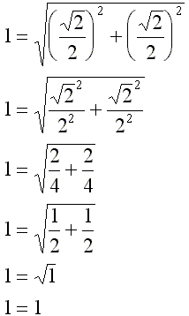
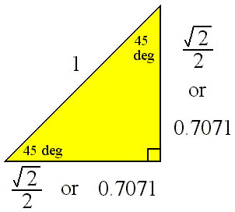
Here we check the values using the Pythagorean theorem.
The length of the hypotenuse should be equal to the square root of the sum of the squares of the legs of the triangle.

Hypotenuse  Length | Leg  Length
1 | 0.7071
1.4142 | 1

Listed in the Table are the values shown in the diagram as well as another common set of values for this triangle. Be sure to notice that the two legs have the same length, so, the leg length is listed only once.

The 30-60-90 Triangle
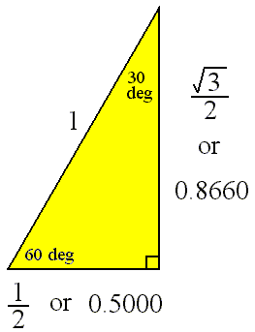
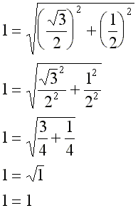
Here we check the above values using the Pythagorean theorem.
The length of the hypotenuse should be equal to the square root of the sum of the squares of the legs of the triangle.
Listed below are the values shown in the diagram as well as another common set of values for this triangle.
Hypotenuse  Length | Leg Length  Opposite 30 Deg | Leg Length  Opposite 60 Deg
1 | 0.5000 | 0.8660
2 | 1 | 1.7320
1.1547 | 0.5773 | 1

